Unit 7
Assignment
Long Vy
Purdue Global
IN450 – Advanced Software Development Using Python
Brian Myers
May 10, 2026
Introduction
Sorting algorithms are foundational to computer science and software engineering. They organize data in a defined order, enabling faster search operations and more efficient data processing overall. This paper documents the implementation and performance evaluation of two sorting algorithms. Bubble Sort and Merge Sort executed against small (10 elements), medium (1,000 elements), and large (10,000 elements) datasets of randomly generated integers. The goal is to observe how each algorithm scales with input size and to evaluate whether targeted optimizations yield measurable performance gains.
Algorithm Selection and Implementation
Bubble Sort was selected as the baseline algorithm because of its simplicity and well-documented behavior. The standard implementation repeatedly compares adjacent elements and swaps them if they are out of order, continuing until no swaps occur in a full pass (GeeksforGeeks, 2024a). Its average and worst-case time complexity is O(n²), making it predictably slow on large datasets but easy to reason about.
A deep copy of the baseline implementation was created for optimization purposes. The primary optimization applied was an early-exit flag. If a complete pass through the array produces no swaps, the array is already sorted and the algorithm terminates immediately. This improvement reduces the best-case complexity from O(n²) to O(n) for already-sorted or nearly sorted input. While this optimization is well-known, it has limited impact on randomly ordered data because swaps continue throughout most passes.
Merge Sort was chosen as the alternative algorithm for comparison. It divides the array into halves recursively, sorts each half, and merges the results (GeeksforGeeks, 2024b). Its time complexity is O(n log n) in all cases, which makes it significantly more efficient than Bubble Sort for large inputs. All benchmarks were conducted using Python's time.perf_counter() function to record start and end timestamps, from which elapsed time was derived.
Results
The following table summarizes the elapsed time in seconds for each algorithm across all three dataset sizes:
Dataset | Bubble sort (baseline) | Bubble sort (optimized) | Merge sort
Small 10 items | 0.000009 s | 0.000007 s | 0.000037 s
Medium 1,000 items | 0.044118 s | 0.046026 s | 0.002173 s
Large 10,000 items | 5.083619 s | 5.243515 s | 0.024015 s

On the small dataset the differences between all three algorithms were negligible, measured in microseconds. The optimized Bubble Sort was marginally faster than the baseline on the small set (approximately 14% improvement), but Merge Sort was slower due to its recursive overhead on tiny arrays.
At the medium scale (1,000 items), the O(n log n) advantage of Merge Sort became pronounced: it completed in roughly 2.2 milliseconds versus approximately 44–46 milliseconds for both Bubble Sort variants, a speedup of over 95%. The optimized Bubble Sort did not outperform the baseline on randomly shuffled data, which is expected because the early-exit condition is rarely triggered when the data is unsorted.
The large dataset (10,000 items) made the performance disparity stark. Baseline Bubble Sort required over five seconds to complete, while Merge Sort finished in approximately 24 milliseconds which is a speedup of approximately 99.5%. The optimized Bubble Sort provided no meaningful improvement over the baseline on random data, confirming that the early-exit optimization only benefits partially or fully sorted inputs.
Conclusion
This experiment demonstrates that algorithm selection has a far greater impact on performance than micro-optimizations applied to an inherently inefficient algorithm. The early-exit improvement to Bubble Sort did reduce iterations on partially ordered data in theory, but on randomly generated datasets it provided no practical benefit. Merge Sort, by contrast, scaled predictably and ran hundreds of times faster on large inputs. These results reinforce the importance of choosing the right algorithmic approach before attempting code-level optimizations, as no amount of tuning can compensate for a fundamentally quadratic time complexity when input sizes grow.

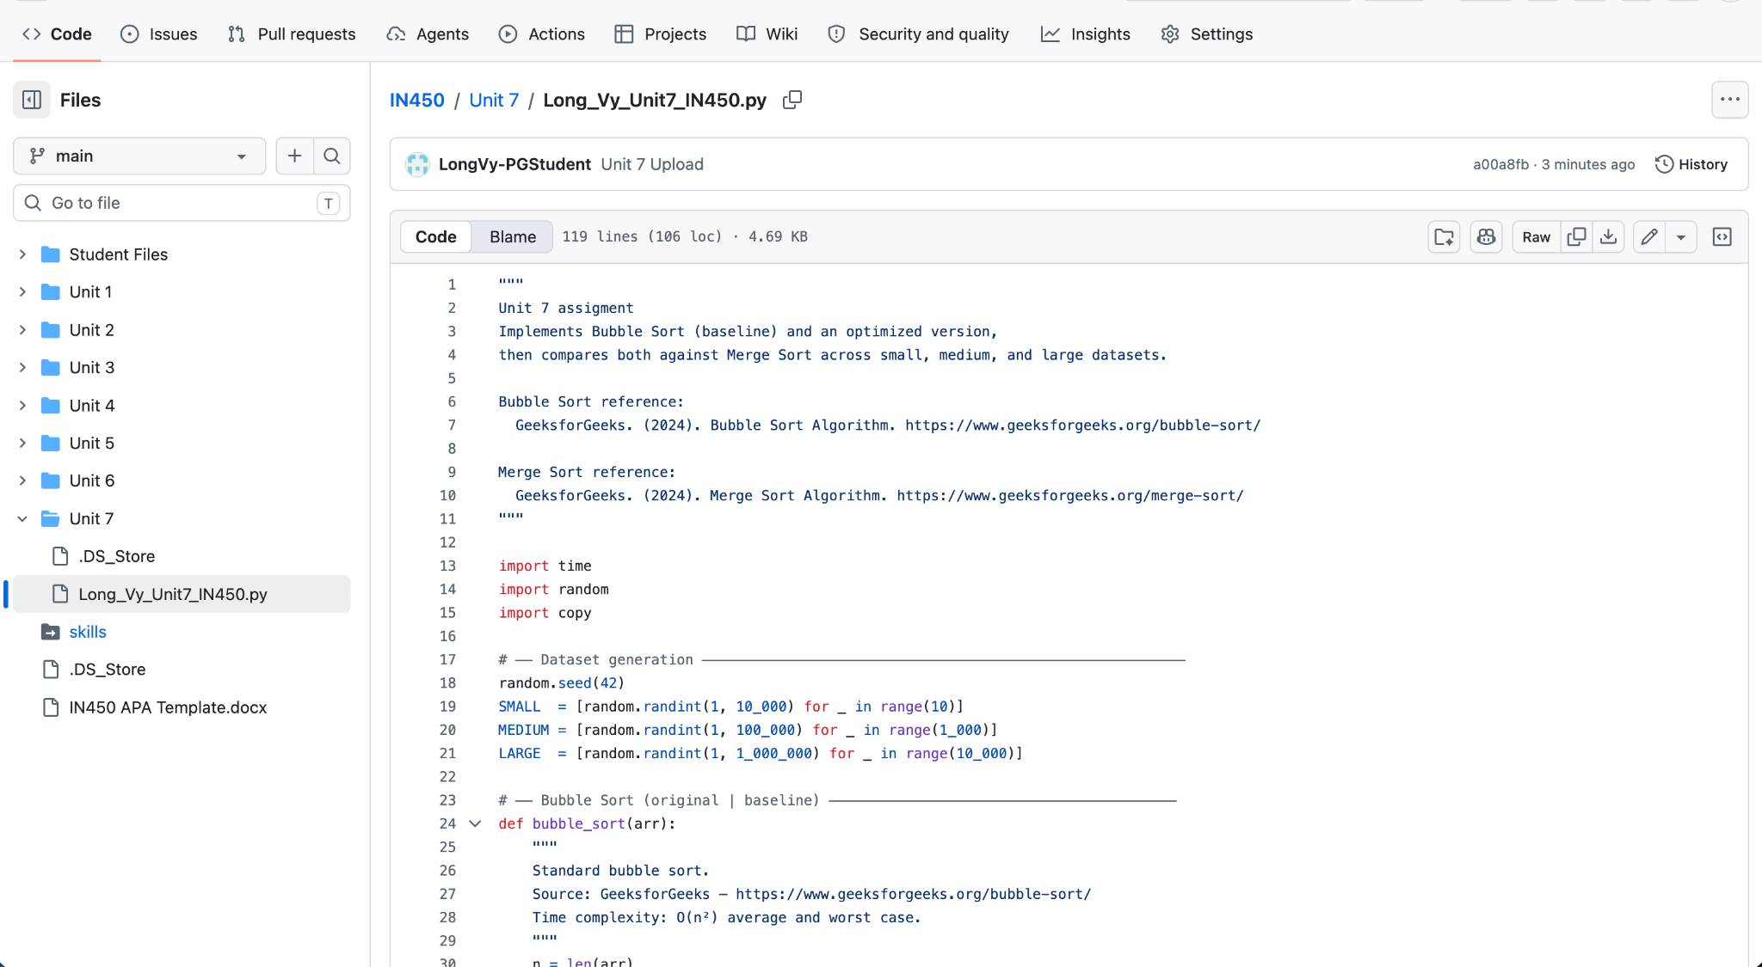

References
GeeksforGeeks. (2025, October 3). Merge sort. https://www.geeksforgeeks.org/dsa/merge-sort/
GeeksforGeeks. (2026, April 21). Bubble sort. https://www.geeksforgeeks.org/dsa/bubble-sort-algorithm/

